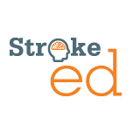
Analysis and retraining of advanced
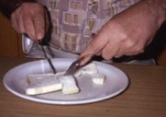
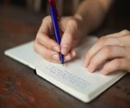
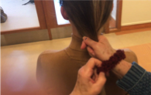
hand coordination post-stroke
Target audience: Occupational therapists, physiotherapists, allied health assistants. No pre-requisites.
Overview: Part 1 - Analysis, 4 hrs: Examples of what to look for when observing a person reach to grasp and manipulate everyday objects such as a cup, knife and fork. Common compensations or kinematic deviations will be highlighted due to weakness and loss of coordination. Part 2 - Task-specific motor training, 4 hrs: Examples will be presented targeting tasks of importance to stroke survivors - using cutlery, handwriting and haircare. In addition to task-specific training, other interventions will include mirror therapy, electrical stimulation, mental practice and constraint-induced movement therapy. A brief summary of the evidence will be presented supporting each intervention.

Learning objectives: Participants will learn how to:
- Name the essential components of reach, grasp and manipulation.
- Recognise common compensations when observing stroke survivors attempting to reach, grasp and manipulate objects.
- Explain how to minimise compensatory strategies or kinematic deviations during upper limb assessment and retraining.
- Plan an assessment and retraining session with a stroke survivor using motor learning principles and task-specific practice.
- Cite references from systematic reviews and national guidelines that support use of mirror therapy, mental practice, electrical stimulation and constraint-induced movement therapy for improving upper limb motor recovery and coordination.
Presenters: Dr Annie McCluskey & Karl Schurr
Date / time: Sat 9th Mar 2021, 08:30-16.00 AEDT
Venue: Fully Online via Zoom
Cost: $220 plus $13.19 Eventbrite admin fee = $233.19
Contact person: dranniemccluskey@gmail.com
Phone: +61 419 447 738 (Annie McCluskey)
More info: http://strokeed.com/

